Understanding Evolution of Cladonia Lichens through Mitochondrial Genome Analysis
Sophia Fratta

Abstract

Emerging advances in the field of bryology indicate that some lichens may have prion-degrading capabilities. In this paper, correlations between prion-degrading properties and genetic differences were investigated in Cladonia lichens, with special emphasis on C. rangiferina, a prion-degrading lichen sometimes called “reindeer lichen.” Using multiple-sequence alignment and pairwise sequence alignment, six mitochondrial Cladonia genomes were analyzed for genomic congruency and phylogeny. We found that the C. rangiferina mitochondrion was not significantly genomically different from other Cladonia lichen mitochondria, nor were any phylogenetic anomalies found that might explain its prion-degrading properties.
Keywords: multiple-sequence analysis, pairwise sequence analysis, genomics, bryology, lichen

Introduction

What Is a Lichen?
Lichens are most well-known in the natural sciences for be- ing symbionts. Traditionally, lichens have been defined as two-part symbionts: the mycobiont, or fungal component, offering structure and nutrients from the ground, and the photobiont (either an algal or cyanobacterial component) contributing through photosynthesis. However, this defi- nition of lichens–the so-called “dual theory of lichens” pro- posed by Swiss botanist Simon Schwender in 1867–provides a deceptively simple picture of lichens.
The dual theory of lichens is commonly accepted to mean two things: firstly, that a lichen consists of two holobionts, and secondly, that those holobionts are in a symbiotic rela- tionship–i.e., they both benefit from the relationship equally. Recent advances in bryology, however, paint a far less cut- and-dry picture. A 2016 study found that Basidiomycete yeasts may constitute a third symbiont in Bryoria lichens [1], but a 2021 study later found that the yeast was not structurally important to the lichen [2]–begging the question, “Why is it part of the lichen at all?” The roles of lichen holobionts are also being called into question, especially as evidence emerges that some holobionts may actually be parasitic.
Perhaps the most vexing area of lichen science to bry- ologists is the question of lichen taxonomy. Traditionally, the lichen has been referred to by its fungal component; for example, the lungwort lichen is referred to as Lobaria pul-

Copyright: © 2020. The authors license this article under the terms of the Creative Commons Attribution 3.0 License.
monaria, after its mycobiont, despite the fact that its photo- biont, Dictyochloropsis reticulata, has an equally important role to play in the organism’s functions. This method of iden- tifying lichens has proved inflexible in the face of lichens’ natural variations: when a third holobiont is found in a previ- ously two-holobiont lichen, how is it referred to? Where are the lines between species? And, perhaps most significantly, in sequencing a lichen’s genome, which holobiont’s DNA is considered to be the lichen’s DNA?

Importance of Lichens to Modern Science
As esoteric and niche as lichens may seem, these questions bear asking. Lichens, after all, are keystone species in many ecosystems; the Cladonia genus–which is examined in this paper–is one of the main food sources for reindeer in the Northern hemisphere. Lichens are also indicators of our planet’s health; despite the fact that they are able to survive exposure to the sun’s rays in outer space, they are extremely sensitive to air quality, and their presence–or absence–can guide us in understanding how much pollution affects local ecosystems.
Perhaps more significant still are the properties of lichens we still fail to understand. A 2011 paper entitled “Degra- dation of the Disease-Associated Prion Protein by a Ser- ine Protease from Lichens” claimed that three species of lichen–namely, Parmelia sulcata, Lobaria pulmonaria, and Cladonia rangiferina–were able to degrade prions through contact with lichens alone. Prions have been responsible for epizootic events in the past and are a significant vector of disease in animal husbandry circles, and, significantly, degrading them with the proteases found in the study has of- ten required extreme environments: “elevated temperatures,

1

the presence of detergents and extreme pH values” [3]. So, although we know that these lichens can degrade prions, there are still significant questions left unanswered: what is the precise mechanism that allows the proteases’ effect in lichens to be so amplified? And why these three species in particular?

Mitochondria As Evolutionary Markers
Because of the complexity of the lichen genome, understand- ing lichen evolution can be difficult. In this study, we used the theory of endosymbiosis as the basis for our analysis. Ac- cording to this theory, ancient eukaryotic cells were ingested by each other through endocytosis. These ingested cells re- mained within the host; and, when the host reproduced, so did the ingested cell–so the two cells became intertwined. The mitochondrion is theorized to be one such cell.
Thus, continuous mutations or other such differences in the mitochondrial genome can be treated as markers of evo- lutionary change. In this study, the mitochondrial genome from lichen mycobionts was used in order to understand the timeline, so to speak, of lichens in the Cladonia genus.

Overall Scope
Our interest here is in understanding the relationships be- tween Cladonia lichens; specifically, understanding any evo- lutionary differences that might set C. rangiferina, a prion- degrading lichen, apart from others of its genus, who have not been shown to have any prion-degrading abilities. We used multiple-sequence alignments and pairwise alignments, as well as phylogenetic trees, to achieve this goal. Namely, we wished to determine (1) whether C. rangiferina was signifi- cantly genomically different, i.e. less than or exactly 95 % genomic congruency to others in its genus, and (2) whether
C. rangiferina broke off from the Cladonia genus tree before others in its genus.

Computational Approach
Two tools were used in the analysis of the data, namely: Clustal Omega, a multiple-sequence alignment technology; and the National Center for Biotechnology Information (hereafter referred to as NCBI) BLAST site, a pairwise- sequence alignment technology. Mitochondrial genomes were obtained through the NCBI GenBank and were not found through the author’s original research.

Data Acquisition
Mitochondrial genomes of Cladonia apodocarpa (voucher: Lendemer 48789; NCBI Accession NC_039372), Cladonia leporina (voucher: 6543; NCBI Accession NC_039662),
Cladonia macilenta (voucher: 49444; NCBI Accession NC_042822), Cladonia petrophila (voucher: Lendemer 49138; NCBI Accession NC_039663), Cladonia rangiferina (voucher: Lendemer 46392; NCBI Accession NC_036309), and Cladonia subtenuis (voucher: Lendemer 49895; NCBI Accession NC_039722), collected and sent for sequencing by C. S. Pogoda, K. G. Keepers, E. A. Tripp, J.C. Lendemer,
N. C. Kane, L. M. Brigham, L. M. Allende, B. R. Shipley,
K. C. Boyd, T. J. Higgins, N. Kelly, C. R. Anderson Stewart,
C. M. Tiehen, D. W. Bailey, were used in order to conduct this analysis.
These genomes were obtained by searching the NCBI Gen- Bank site, keywords being “[species name] mitochondrion”. Once each species’ mitochondrial genome page was navi- gated to, the genome sequences were downloaded as FASTA files.

Multiple Sequence Alignment
The multiple sequence alignment site Clustal Omega ( was then used to perform the next step of the analysis. The se- quences were submitted for processing with the following parameters: sequence type: DNA; dealign input sequences: no; mBed-like clustering guide-tree: yes; mBed-like clus- tering iteration: yes; number of combined iterations: 0; maximum guide-tree iterations: -1; maximum HMM iter- ations: -1; order: aligned. These parameters, excepting the sequence type, are default for Clustal Omega multiple sequence alignments.

NCBI BLAST and Distance Trees
Using NCBI BLAST (nucleotide-nucleotide), each FASTA sequence was blasted. Results were sorted by percent entire (ascending-descending) in order to verify that the mitochon- drial genomes had been correctly identified.
Distance trees for all six cladonia lichens were obtained through BLAST results. For Figs. 5 - 9, the parameters were set as follows: tree method: fast minimum evolution; maximum sequence difference: 0.75; sequence label: se- quence title; sorting: do not sort. For Fig. 5, an ascomycete fungi containing four extraspecial nodes was collapsed for viewing clarity. For Fig. 6, all nodes were expanded. For Figs. 7, 8, and 9, all nodes from genuses other than Clado- nia were closed, excepting those used for comparison. For Fig. 10, all nodes from genuses other than Cladonia were collapsed; in addition, parameters were changed as follows: tree method: fast minimum evolution; maximum sequence difference: 0.75; sequence label: sequence title; sorting: sort by distance.

Data Analysis Using Phylogenetic Trees
In order to conduct an analysis of the selected six mitochon- drial genomes, both versions of the phylogenetic tree were examined, i.e., with cladogram branches and real branches. We examined the number of clades and nodes using the cladogram; we used the real branches to judge genetic dif- ferences graphically. This information was supplemented by the guide tree data provided with the phylogenetic tree.

Data Analysis Using Percent Identity Ma- trix and NCBI Percent Identity
Using the percent identity matrix generated by the Clustal Omega multiple sequence alignment, a data table compar- ing the six mitochondrial genomes of the selected lichen was constructed in Microsoft Excel; see Fig. 9. In a similar fash- ion, the data from the “percent identity” columns in NCBI BLAST results were transferred to a table in Microsoft Excel in order to conduct a comparison between lichen genomes.

Data Analysis Using Distance Trees
In order to analyze the distance trees, the number of clades in each tree as well as the umber of nodes in each clade per tree were compared. In trees where the outgroup was different, the number of nodes were counted from a fixed starting point (namely, C. rangiferina), in order to determine the sequence of the outgroups.

Results

Phylogenetic Trees
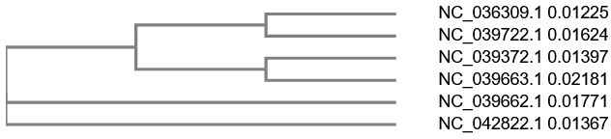
Figure 1: Phylogenetic tree with cladogram branches de- scribing six mitochondrial genomes of Cladonia lichen: C. rangiferina, C. subtenuis, C. apodocarpa, C. petrophila, C. leporina, C. macilenta (descending).

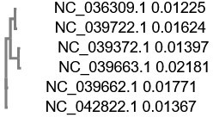
Figure 2: Phylogenetic tree with real branches describing six mitochondrial genomes of Cladonia lichen: C. rangiferina,
C. subtenuis, C. apodocarpa, C. petrophila, C. leporina, C. macilenta (descending).
The two phylogenetic trees derived from the Clustal Omega multiple sequence analysis describe C. rangiferina, C. sub- tenuis, C. apodocarpa, and C. petrophila as being mono- phyletic, with C. leporina and C. macilenta belonging to separate clades–not outgroups. Within the monophyletic group, C. rangiferina and C. subtenuis display monophyly, as well as C. apodocarpa and C. petrophila.
The tree data is as follows:
(
(
( NC_036309.1:0.01225, NC_039722.1:0.01624)
:0.03760, (
NC_039372.1:0.01397, NC_039663.1:0.02181)
:0.06471)
:0.03585, NC_039662.1:0.01771, NC_042822.1:0.01367);

Percent Identity Matrix and NCBI Per- cent Identity Data
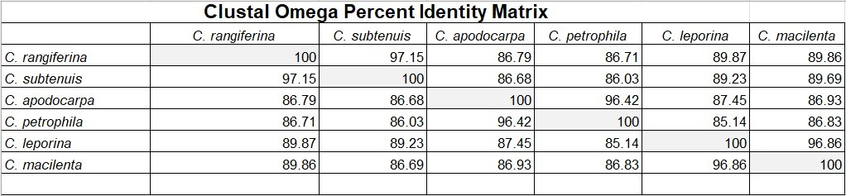
Figure 3: Table entitled “Clustal Omega Percent Identity Matrix.” Values are displayed as a score out of 100, where 0 represents no relation between genomes and 100 repre- sents genome congruency.

The percent identity matrix generated by the Clustal Omega multiple sequence alignment describe C. subtenuis and C. rangiferina as having the highest genome congruency and
C. subtenuis and C. petrophila as having the lowest genome congruency. C. apodocarpa and C. petrophila also had high genome congruency (less than or exactly 95%). These data support the relationships represented by both Clustal Omega phylogenetic trees.
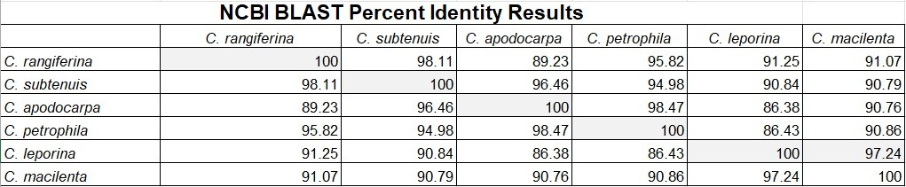
Figure 4: Table entitled “NCBI BLAST Percent Identity Re- sults.” Values are displayed as a score out of 100, where 0 represents no relation between genomes and 100 represents genome congruency.

The percent identity data generated by NCBI blast de- scribe C. apodocarpa and C. petrophila as having the high- est genome congruency and C. petrophila and C. leporina as having the lowest genome congruency. The following pairs also had high genome congruency (less than or exactly 95%): C. rangiferina and C. subtenuis; C. rangiferina and C. petrophila; C. leporina and C. macilenta.

Distance Trees
In examining the distance trees, it was determined that the pairs C. rangiferina and C. subtenuis, C. macilenta and C. leporina, and C. apodocarpa and C. petrophila were all mono- phyletic. Furthermore, C. rangiferina, C. subtenuis, C. maci- lenta, and C. leporina all belonged to one clade, while C. apodocarpa, C. petrophila, and previously unexamined C. peziziformis belonged to another clade.
In addition, C. rangiferina was found to be ten nodes distant from Ophiostoma himal-ulmi, an Ophiostomataceae fungus endemic to the Himalayas, and Cladophialophora bantiana, a Herpotrichiellaceae fungus known to cause brain abscesses. C. rangiferina was also found to be six nodes dis- tant from Phyllopsora corallina, a Ramalinaceae lichenized coral fungus.

Conclusion

Understanding C. rangiferina’s Phyloge- netic Position
Our initial hypothesis was that C. rangiferina would display significant genome dissimilarity with others in the Clado- nia genus, and that it would have an earlier break from the Cladonia genus in the phylogenetic tree. In conducting our analysis with Clustal Omega, we found that, in both phy- logenetic trees, C. rangiferina was closely related with C. subtenuis, C. apodocarpa, and C. petrophila Indeed, C. lep- orina and C. macilenta appeared to be less closely related to the other four lichen genomes. This data did not support our hypothesis that C. rangiferina would be significantly different from others in its genus.
The distance trees displayed slightly altered data; C. rangiferina displayed monophyly with C. subtenuis and close relation to C. leporina and C. macilenta, and was more distantly related to C. peziziforma, C. apodocarpa, and C. petrophila. These data were consistent across all six dis- tance trees generated by the NCBI BLAST. While there are differences between the phylogenetic trees and the distance trees, all of the data support the conclusion that C. rangife- rina did not, in fact, have any significant evolutionary break from the Cladonia genus.

C. rangiferina in Relation to Other Clado- nia Lichens
The NCBI BLAST percent identity results and Clustal Omega percent identity matrix also do not support the initial hypothesis that C. rangiferina would have no genome con- gruency levels higher than 95%. The BLAST percent iden- tity results indicated that C. rangiferina had high genome congruency levels with C. subtenuis and C. petrophila; the percent identity matrix indicated that C. rangiferina had high genome congruency levels with C. subtenuis. Again, the re- sults differ, but none of them support the initial hypothesis.
C. rangiferina is mainly found in the northern hemisphere, particularly in Canada’s boreal forests; however, it can be found throughout the East coast of the United States and in the United Kingdom. C. subtenuis and C. petrophila are mostly found throughout the East coast of the United States, although C. petrophila has also been found in tropical regions. We suggest that the East coast geographic overlap may offer clues as to these lichens’ genomic similarities.

Variations Across Datasets
Differences in the results across may be attributed to the differences in alignment programs; i.e. Clustal Omega is a multiple-sequence alignment program, and NCBI is a pairwise-sequence alignment program. As a rule, we re- garded the NCBI BLAST results as more accurate, as a 2006 study suggested that Clustal Omega results were not as accurate as those of other alignment tools[4]. However, this study is older than ten years old and compared protein- protein sequences; thus, we chose not to disregard Clustal Omega results entirely, instead using it as a supplement. Significant differences between phylogenetic trees, however, warrant further investigation into the accuracy of the align- ments.

Further Areas of Study
Further research into C. rangiferina is also warranted. While genomic differences may not account for its prion degrading capabilities, there are many areas of study; namely, do lichen compounds affect the serine proteases’ effectiveness? While some testing of compounds was undertaken in the original 2011 study, it was not conclusive enough to rule out the possibility. A genomic analysis of C. rangiferina may also be useful in determining the exact serine protease or proteases responsible for degrading prions in lichens.

Acknowledgements
Special thanks are given to NCBI GenBank for providing access to genomic data.

References
- Purdue University. (2016, July 21). Yeast emerges as hidden third partner in lichen symbiosis.
ScienceDaily. Retrieved May 20, 2022 from www.sciencedaily.com/releases/2016/07/160721151213.htm.
- Mark, K., Laanisto, L., Bueno, C. G., Niinemets, Ü., Keller, C., & Scheidegger, C. (2020). Contrasting co-occurrence patterns of photobiont and cystobasid- iomycete yeast associated with common epiphytic lichen species. New Phytologist, 227(5), 1362-1375.
- Johnson, C. J., Bennett, J. P., Biro, S. M., Duque- Velasquez, J. C., Rodriguez, C. M., Bessen, R. A., & Rocke, T. E. (2011). Degradation of the disease- associated prion protein by a serine protease from lichens. PLoS One, 6(5), e19836.
- Nuin, P. A., Wang, Z., Tillier, E. R. (2006). The accuracy of several multiple sequence alignment programs for proteins. BMC bioinformatics, 7(1), 1-18.

Supplemental
Below are the distance trees generated by NCBI BLAST.
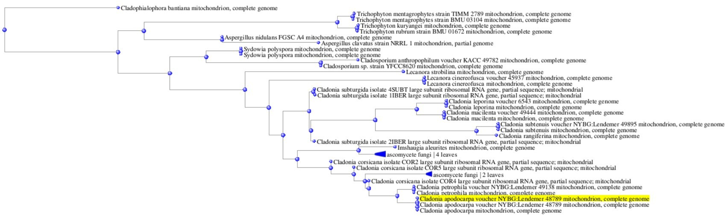
Figure 5: Distance tree generated by C. apodocarpa through NCBI BLAST.

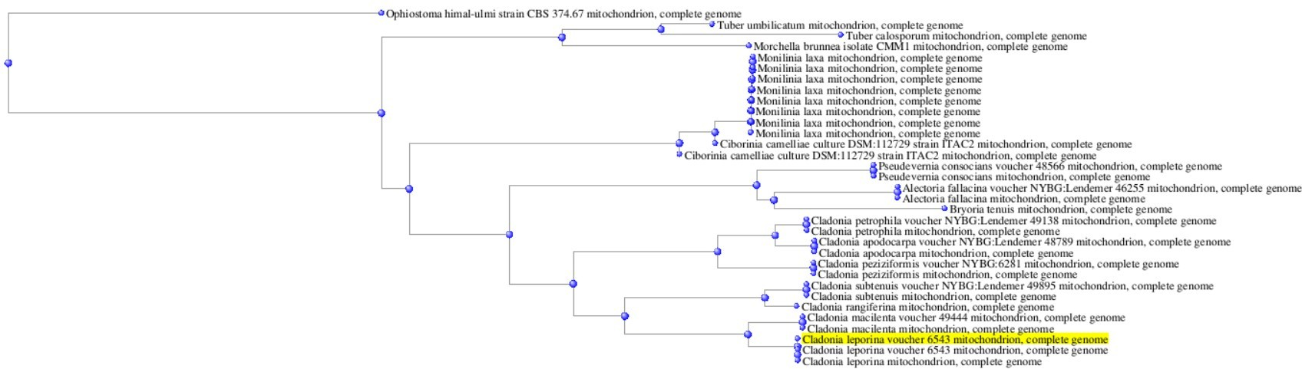
Figure 6: Distance tree generated by C. leporina through NCBI BLAST.

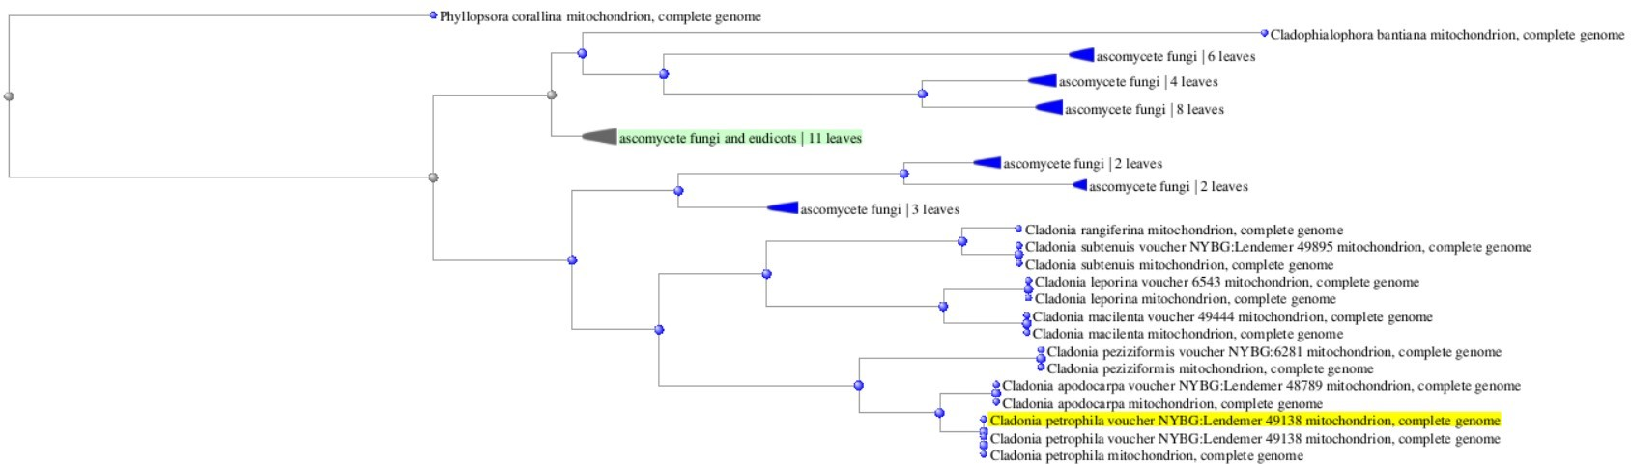
Figure 7: Distance tree generated by C. petrophila through NCBI BLAST.

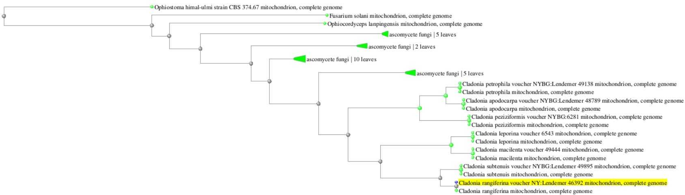
Figure 8: Distance tree generated by C. rangiferina through NCBI BLAST.

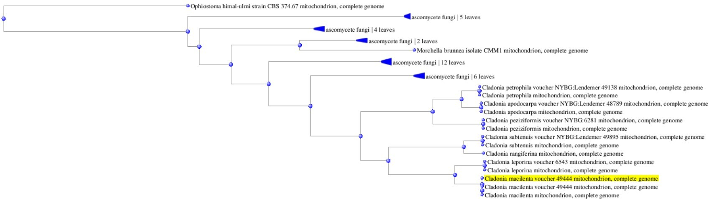
Figure 9: Distance tree generated by C. macilenta through NCBI BLAST.

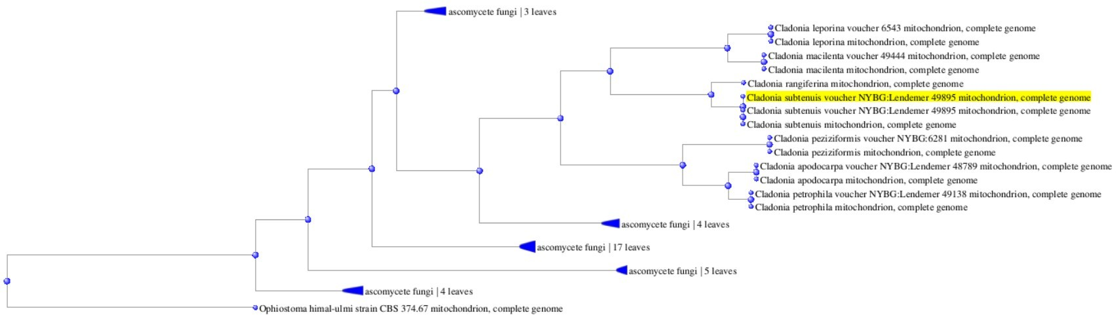
Figure 10: Distance tree generated by C. subtenuis through NCBI BLAST, sorted by distance.

